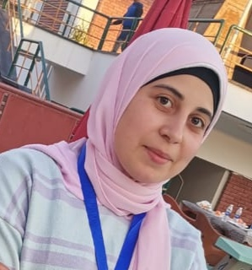
Address:
Nile Street, Majris vallige, Sedfa center , Assuit Governorate.

Phone:
01066051505
Email:
amlm@nursing. aun.edu.eg

Languages
- Arabic
- English

Skill Highlights

- Problem solving.
- Time management
- Handling pressure.
- Adaptability.
- Good leader.

Education
Bachelor of Nursing: Demonstrator in geriatric department.

Certifications
- Mechanical ventilator training (2017).
- First aids ( 2017).
- Elementary level course ( December 2020).
- IC3 GS5 Course (from September to October 2020).
- Publication of research in international journal( NOV2020).
- Crisis management (NOV2020).
- Quality standers in teaching (NOV2020).
- Summation of research paper to Assuit scientific journal( Sep2020).

